Complete Proof of Intelligence
Consensus Architecture
A Single-Pass, Optimistic, EVM-Compatible Protocol for Frontier-Scale Verifiable AI Responses
Formal Protocol and Systems Proposal • August 2026

Core design decision
A consensus-eligible AI response must be generated once by the registered frontier model. Verification is performed from committed execution traces, evidence capsules, post-commit randomized audits, optimistic dispute games, and explicit assurance tiers. A second full-model generation and a full per-response zkML proof are not mandatory.

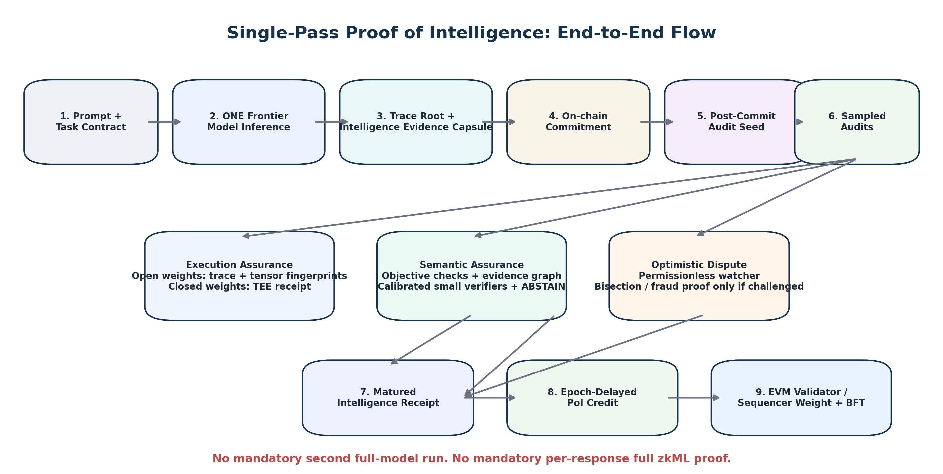
Figure 1. Single-pass end-to-end PoI flow: one frontier inference, post-commit audits, matured receipt, and next-epoch consensus authority.
Research status: complete theoretical architecture and implementation blueprint. Security, semantic-accuracy, economics, throughput, and production claims remain conditional on executed validation gates.

Executive Summary
The expensive part of a modern AI service is the frontier-model inference itself. A Proof of Intelligence protocol that requires the same large model to run a second time for every accepted response, or that requires a full zero-knowledge proof of every tensor operation, creates a structural cost barrier. This architecture removes both requirements from the common path. The worker executes the requested model once, emits the user-facing response, and simultaneously commits enough execution and semantic evidence to make the response auditable after the fact.
The protocol centers on a proposed reusable abstraction called Single-Pass Auditable Intelligence (SPAI). SPAI treats one committed response as the intelligence event. After commitment, protocol randomness selects computational and semantic audit obligations. The worker opens committed trace regions and evidence, but does not need to invoke the frontier model again. Open-weight models use algebraic tensor audits, exact checks for cheap operations, and an optimistic fraud-proof backstop. Closed/proprietary models use confidential-computing attestation and policy-gated key release, with lower assurance unless independent cryptographic audit surfaces are available. Semantic correctness is verified with deterministic task checks, evidence-grounded claim verification, calibrated small verifier programs, and a fail-closed ABSTAIN state.
Consensus is deliberately asynchronous. Work completed in epoch e is audited and challenged before it can produce authority in epoch e+1. This means the chain never waits at block speed for a 70B, 600B, or mixture-of-experts model to be proven. EVM contracts manage commitments, challenge windows, receipts, task credit budgets, and slashing; a custom EVM appchain/L2 or EVM L1 consensus client consumes matured PoI weight for validator or sequencer selection.
Design requirement | Architectural response
No second frontier-model run | One response plus committed trace and Intelligence Evidence Capsule; post-commit audits open existing evidence.
Avoid mandatory full zkML | Optimistic execution assurance: tensor fingerprints, exact local checks, TEE attestation, and fraud-proof escalation.
Support frontier / distributed / MoE models | Sharded trace roots, active-expert auditing, multi-GPU attestation, batched audits, asynchronous receipt maturity.
Trustworthy answer quality | Task-relative semantic contracts, objective/grounded checks, calibrated verifier programs, ABSTAIN for underdetermined semantics.
EVM implementation | Solidity registries, commitment hub, audit/dispute contracts, receipt manager, credit engine, and consensus adapter.
Consensus scalability | Verified work is converted into next-epoch authority; expensive AI work never executes inside the EVM.

1. Problem Definition and Non-Negotiable Requirements
Proof of Intelligence must not collapse into Proof of Hardware, Proof of Model Hash, Proof of Inference, or an opinion-weighted reputation market. The consensus resource must be a real prompted response that was produced by the requested model, whose computation is sufficiently auditable, and whose task-relevant correctness or usefulness is operationally verified.
Model identity != execution integrity != response competence != consensus security
A complete architecture must satisfy all four layers. It must also remain practical when the requested model is much larger than the models that can be efficiently placed inside current proof circuits. Current optimistic-ML work shows that fraud-proof approaches can avoid the full cost profile of zkML [1], and production-facing LLM audit prototypes show that large linear layers can be checked with randomized algebraic fingerprints while keeping normal GPU serving on the main path [5]. These techniques are useful foundations, but they do not by themselves establish that the user-facing answer is intelligent.
The protocol therefore adopts the following hard requirements:
- Exactly one required execution of the user-requested frontier model per response.
- No mandatory full per-response zkML proof.
- Permissionless post-commit auditability with a trust-minimized dispute path.
- Explicit support for dense, sharded, and mixture-of-experts inference.
- No worker or validator reputation inside the per-response validity predicate.
- Service work may be paid, but arbitrary self-created service work cannot mint consensus authority.
- Open-ended semantic uncertainty must fail closed rather than be converted into false certainty.
- EVM-based deployment must keep heavy AI execution off-chain and keep on-chain operations bounded.
Important boundary
A smart contract deployed on Ethereum cannot replace Ethereum proof-of-stake. On Ethereum mainnet, this protocol is an application/L2 settlement and sequencer-selection mechanism. A genuine PoI consensus chain uses an EVM execution layer with a custom consensus client, or an EVM L2/appchain whose validator/sequencer set is selected from PoI weight.

2. Core Primitive: Single-Pass Auditable Intelligence (SPAI)
SPAI is the protocol abstraction that replaces the expensive “run the large model again” verification pattern. The worker runs the requested model once. During that run, a trace sidecar and evidence builder create commitments to computational and semantic audit surfaces. After the response is irrevocably committed, protocol randomness selects which surfaces must be opened and verified.
SPAI does not claim that commit-audit or fraud-proof techniques are new. The proposed primitive-level object is the accepted intelligence event: one prompted response, one model execution, one committed trace/evidence state, unpredictable post-commit audits, and a maturity rule that turns only successfully audited events into consensus resources.

2.1 SPAI syntax
Algorithm | Purpose
Setup(policy, model) | Registers model manifest, runtime profile, audit rules, verifier programs, task families, proof/dispute parameters, DA rules, and economic limits.
ExecuteOnce(T, x, M) | Runs the requested model once and outputs response y, execution-trace root R_X, and Intelligence Evidence Capsule root R_E.
Commit(...) | Publishes a binding commitment C_R before the protocol chooses concrete audit samples.
Sample(C_R, beacon) | Derives computational sample set S_X and semantic obligation set S_S from post-commit randomness.
Open(S_X, S_S) | Opens only the committed trace/evidence regions needed by the selected audits.
Verify(...) | Checks model/runtime binding, sampled execution integrity, semantic obligations, freshness, DA, and policy state.
Dispute(...) | If a watcher finds an invalid claim, invokes the optimistic dispute game and slashing path.

2.2 Base commitment
C_R = H(domain || C_T || C_M || H(y) || R_X || R_E || C_A || sampling_manifest || nonce)
C_T is the task contract; C_M is the exact model/runtime manifest; R_X is the execution-trace commitment; R_E is the Intelligence Evidence Capsule root; C_A is the off-chain artifact commitment. Every field that can affect the output or its interpretation is domain-separated and bound before the audit seed exists.

2.3 Post-commit audit seed
eta = H(domain_audit || EpochBeacon || C_T || C_R || audit_round)
(S_X, S_S) = AuditCompiler(policy, task_family, eta)
The worker may know the audit distribution, but cannot know the concrete audit sample before C_R is finalized. A worker-controlled VRF is not used as the sole randomness source. The protocol uses an epoch beacon or threshold randomness source whose bias assumptions are part of the chain security model.

2.4 SPAI acceptance relation
V_SPAI = V_model AND V_runtime AND V_exec-audit AND V_semantic AND V_fresh AND V_DA AND V_policy
An accepted SPAI event becomes a candidate Intelligence Receipt. Consensus authority is not immediate: the receipt must also survive its challenge and retention window.
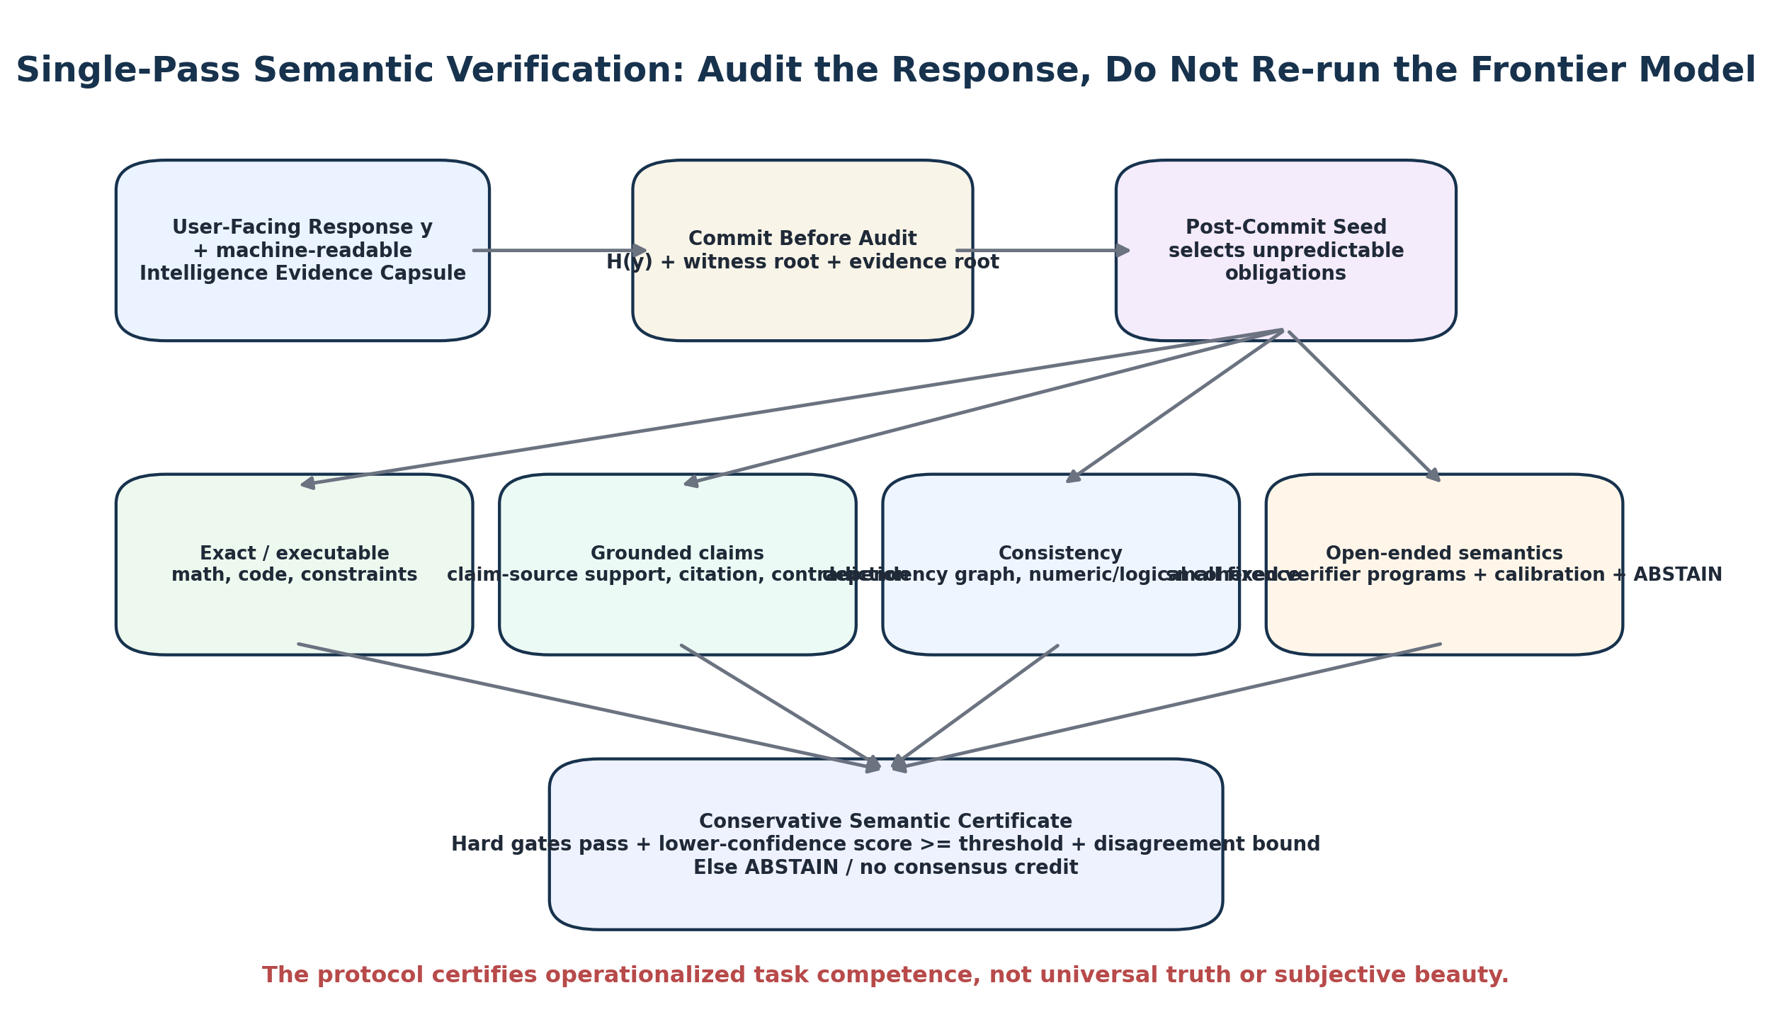
Figure 2. Semantic verification is performed against the committed response and its evidence capsule; the frontier model is not re-run.

3. Frontier-Scale Execution Assurance Without Mandatory Full zkML
The architecture separates execution assurance into two interoperable lanes. The open-weight lane targets trust minimization. The confidential lane targets proprietary frontier models. Both lanes expose an explicit assurance tier in the final receipt, so weaker hardware-root assumptions cannot silently masquerade as full cryptographic proof.
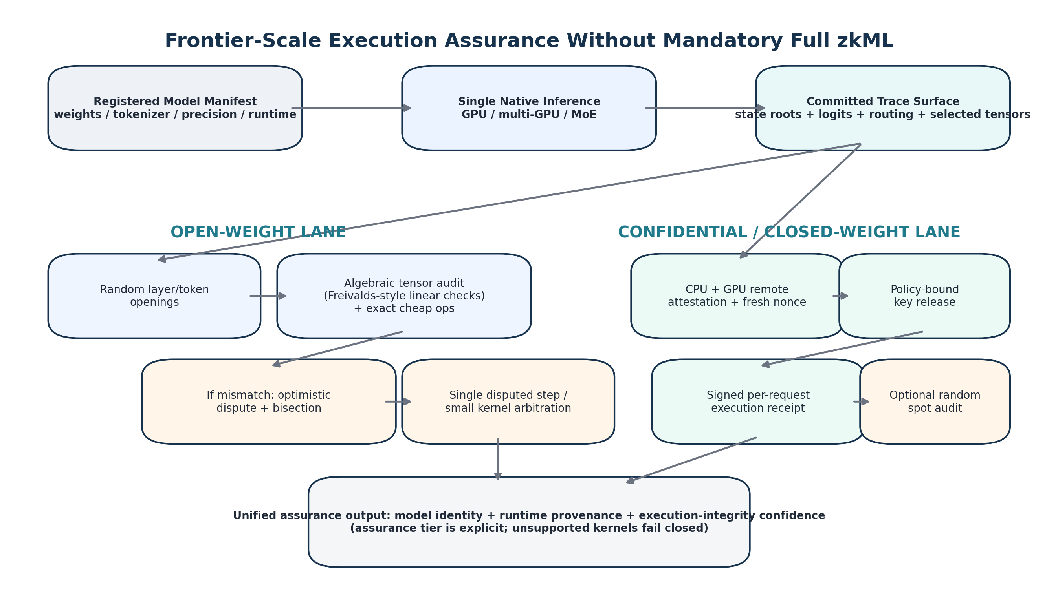
Figure 3. Open-weight and confidential execution-assurance lanes converge into one explicit assurance object.

3.1 Open-weight lane: committed trace plus algebraic audit
Large transformer inference is dominated by matrix products. Recomputing every product defeats the purpose of verification. Freivalds-style randomized checks verify a claimed matrix product much more cheaply than recomputing the full matrix multiplication, with soundness amplified by independent challenges [6]. Contemporary LLM audit prototypes use this approach for transformer linear layers while committing the execution trace and replaying cheaper nonlinear steps [5].
For claimed z = W x, choose random r after commitment and verify: r^T z = (r^T W) x
For blockchain use, the random audit vector is not exposed before the provider has committed the trace. Auditors can maintain private audit keys or derive epoch-specific challenge vectors after batch commitments. The common case is CPU-only/off-chain verification; an on-chain dispute occurs only when a mismatch is found.

3.2 Exact and bounded checks for non-linear operations
Layer normalization, activation functions, quantization bridges, sampling rules, tokenization, routing decisions, and decode policy are verified either by canonical recomputation on opened states, by range/lookup checks, or by a small dispute VM. Attention requires special treatment because optimized GPU kernels can have non-trivial floating-point execution paths. The protocol therefore supports three statuses per kernel: VERIFIED, ATTESTED, or UNSUPPORTED. Unsupported kernels fail closed for the highest consensus assurance tier.
Practical evidence is encouraging but incomplete. The CommitLLM prototype reports approximately 12-14% online tracing overhead and very low CPU audit time for selected Llama 70B traces, while explicitly noting that arbitrary-position stock-kernel attention remains outside its fully verified surface [5]. This architecture treats that limitation as a protocol-level assurance downgrade rather than hiding it.

3.3 Optimistic dispute game
A candidate receipt is assumed valid unless a bonded watcher challenges it. This follows the same structural logic as optimistic rollup fault proofs: committed execution is bisected until the parties isolate a disputed state transition; a small deterministic arbitration step is then resolved by the settlement contract or dispute VM [1,2].
- Worker posts a response/trace commitment and bond.
- Permissionless watchers inspect sampled trace openings and semantic artifacts off chain.
- A watcher that finds an inconsistency posts a challenge bond and disputed trace interval.
- Interactive bisection reduces the disagreement to a small deterministic transition.
- The final step is resolved on chain by a bounded verifier, or by a tiny validity proof if the selected kernel is not economically expressible directly in EVM.
- Loser is slashed; winner receives a protocol-defined challenge reward.
The tiny-proof fallback is deliberately not the common path. It proves only a disputed micro-step, not the full model inference. Thus full zkML becomes an optional dispute primitive rather than a per-query cost.

3.4 Confidential / proprietary model lane
Closed-weight frontier models cannot expose W for public tensor checks. For this lane, the protocol uses confidential-computing attestation and policy-gated key release. NVIDIA documents CPU/GPU attestation flows in which a fresh nonce binds measurements of the approved guest, hardware, firmware, and policy state before an encrypted model key is released into the confidential VM [4]. Current attestation stacks support H100-class and later GPU confidential-computing environments; composite CPU/GPU attestation is also available from independent attestation services [7].
A proprietary-model receipt therefore proves execution provenance rather than full mathematical model execution. To avoid overstating security, confidential receipts receive a lower assurance factor unless they are supplemented by open audit commitments, independent attestation domains, or provider-supported algebraic verification keys.

3.5 Multi-GPU and MoE scaling
Frontier inference is frequently distributed. The model manifest therefore commits a shard/expert topology, tensor-parallel configuration, router policy, tokenizer, precision, and runtime. Each device or process creates a local trace root; the job root commits all local roots plus cross-device message digests.
R_X = MerkleRoot(R_shard_1, ..., R_shard_m, router_root, KV_root, decode_root)
For mixture-of-experts models, verification scales with the active path rather than the entire parameter count. The protocol audits router decisions and only the experts actually executed for selected tokens. Inactive experts remain part of the model registry commitment but do not add per-response audit cost. Multi-GPU/nvSwitch attestation can be used for the confidential lane, while open-weight tensor audits are sharded by the same execution topology.

4. Verifying Intelligence Without a Second Frontier-Model Generation
The response itself must carry enough structure to support post-commit verification. The architecture therefore defines an Intelligence Evidence Capsule (IEC). The capsule is created during the same request lifecycle as the user response; it can be emitted as structured auxiliary output or built by a deterministic sidecar from the response, evidence sources, tool outputs, and runtime metadata. It is not private chain-of-thought and does not require internal reasoning disclosure.

4.1 Intelligence Evidence Capsule
IEC field | Purpose
Claim nodes | Atomic factual, computational, recommendation, or constraint claims extracted from the response.
Evidence roots | Hashes/references to task-authorized documents, tool outputs, databases, code results, or public data.
Dependency edges | Which claims depend on which evidence, calculations, assumptions, or constraints.
Uncertainty tags | Confidence bands or explicit underdetermination markers required by policy.
Executable artifacts | Code, calculations, plans, or structured outputs that can be independently checked.
Coverage map | Maps task requirements to response spans/claim nodes so audit sampling is measurable.

4.2 Semantic audit classes
Class | Task type | Verifier path | Consensus eligibility
O - objective | Math, SAT/CSP, code, structured transformations | Deterministic checker / tests / exact constraints | Highest
G - grounded | RAG, evidence-grounded QA, data analysis, cited explanation | Claim-evidence checks + contradiction/provenance + calibrated semantic programs | High / capped by calibration
S - open semantic | General explanation, advice, style-constrained generation | Fixed small verifier programs + rubric + LCB + disagreement + ABSTAIN | Capped; task-family quota
U - underdetermined | Beauty, moral correctness, culture-dependent or undefined predicates | No authoritative verifier | NOT ELIGIBLE / ABSTAIN

4.3 Post-commit semantic audit
After C_R finality, S_S selects obligations such as claim-source support, hidden task constraints, contradiction detection, evidence deletion sensitivity in the dependency graph, numerical consistency, citation validity, executable test coverage, and uncertainty requirements. These obligations inspect the already committed response and IEC. They do not ask the frontier model to produce a second answer.
mu_j = weighted_mean(z_j1, ..., z_jK)
LCB_j = clip(mu_j - lambda * sigma_j, 0, 1)
ACCEPT only if hard_gates = 1, aggregate_LCB >= tau, disagreement <= gamma, calibration_valid = 1
Semantic verifier programs are not validators with discretionary voting power. Their model hash, prompt/template, decoding mode, calibration anchors, and allowed task classes are fixed by the active policy. Where their error is too high or correlated disagreement is excessive, the protocol returns ABSTAIN and mints no consensus credit.
Scientific limit
No cryptographic protocol can prove that a poem is universally beautiful or that advice is universally wise unless those properties are operationalized into a defensible relation. This architecture achieves globally auditable task-relative competence, not metaphysical proof of intelligence.

5. Complete Proof of Intelligence Architecture

Figure 4. Complete architecture. Heavy AI work and routine verification stay off chain; the EVM consumes compact commitments, disputes, receipts, and credit state.
Layer | Core object / invariant
Policy | C_P binds model rules, task families, audit compiler, semantic verifiers, DA, disputes, economics, and upgrades.
Task | C_T binds prompt/input root, model, task class, consensus eligibility, budget, deadline, and nonce.
Model / runtime | C_M binds exact artifact or confidential-model manifest, tokenizer, precision, sharding/MoE policy, and runtime.
Execution | One native inference produces y and committed trace root R_X.
Intelligence | IEC root R_E binds claims, evidence, dependencies, constraints, and uncertainty.
Audit | Post-commit eta selects S_X and S_S; no second frontier inference is required.
Dispute | Permissionless optimistic challenge path arbitrates invalid execution or protocol faults.
DA / receipt | Artifacts must remain retrievable through the challenge/slashing horizon before authority matures.
Resource | Matured receipts create bounded next-epoch intelligence credit.
Consensus | PoI weight selects validator/sequencer committees; BFT/fork-choice provides agreement.

6. End-to-End Protocol
Phase | Protocol action
1. Admit task family | Governance defines objective, grounded, open-semantic, and non-eligible dimensions; false certainty is prohibited.
2. Freeze epoch policy | Commit C_P including audit compiler, verifier programs, model profiles, dispute rules, DA and economic parameters.
3. Register model | Publish C_M; open weights use a Merkleized manifest; closed models use confidential-artifact and attestation policy.
4. Schedule PoI task | Protocol creates C_T with task family, model, global task budget D_j, deadline, audit class, and nonce.
5. Assign task Sybil-neutrally | Assignment probability and total task credit are independent of wallet count; task budgets belong to task instances.
6. Execute once | Worker runs the requested frontier model once and produces response y.
7. Build audit surfaces | Trace sidecar produces R_X; IEC builder produces R_E; artifacts are prepared for DA.
8. Commit response | Worker posts C_R and bond. No concrete audit sample is known yet.
9. Finalize commitment | Settlement chain finalizes C_R or reaches the policy-defined irreversible checkpoint.
10. Reveal audit seed | Epoch beacon derives eta and concrete computational/semantic sample sets S_X and S_S.
11. Routine off-chain audit | Auditors check trace openings, tensor fingerprints, semantic obligations, DA, and policy state.
12. Optional dispute | Any auditor can challenge; interactive fault proof localizes the invalid transition or protocol fault.
13. Candidate receipt | If common-path checks pass, a candidate Intelligence Receipt is created in PENDING state.
14. Challenge / retention window | Receipt remains non-authoritative while challenge and DA retention obligations remain open.
15. Mature receipt | After the window closes without successful challenge, receipt becomes ACTIVE.
16. Allocate bounded credit | CID/task class/quality/assurance determine c_ij, subject to per-task budget D_j and family caps.
17. Activate next-epoch weight | Verified work from epoch e contributes to Q_i^(e+1), never to the consensus slot currently being verified.
18. Select committee and finalize | Consensus client samples validator/sequencer committee from W_i^(e+1); weighted BFT/fork-choice finalizes blocks.

7. Cost Model and Why Single-Pass Matters
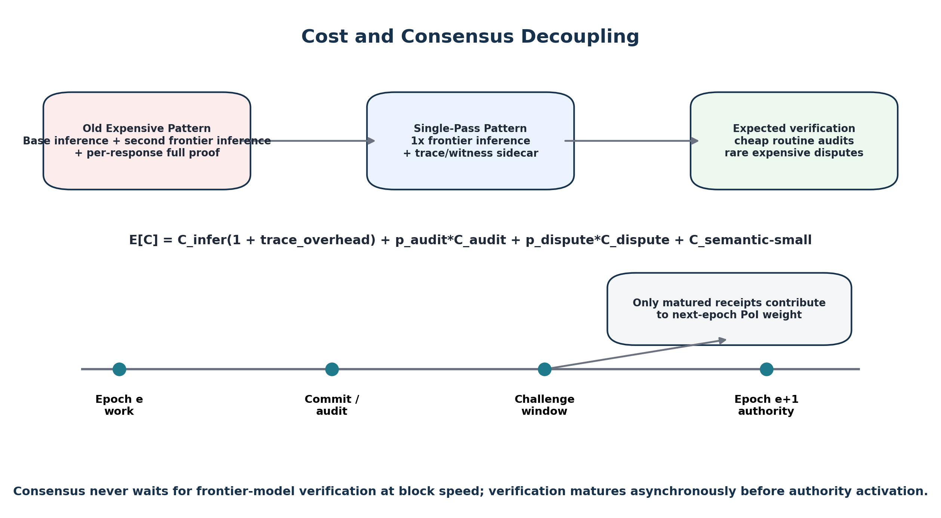
Figure 5. Expected cost removes the mandatory second frontier inference and decouples audit finality from block finality.
A two-run challenge architecture has a structural lower bound near two model generations before proof cost is considered. SPAI changes the common path to one inference plus trace/evidence overhead and sampled audits.
E[C_SPAI] = C_infer*(1 + tau_trace) + p_a*C_audit + p_d*C_dispute + C_sem-small
tau_trace is the online trace/commit overhead, p_a is the routine audit rate, and p_d is the dispute probability. Because p_d should be small under rational staking and because routine audits sample only committed regions, the expected common-case cost can be far below a second full inference. The protocol does not assume any specific percentage for tau_trace across all models; it is an implementation metric that must be benchmarked. Existing LLM audit prototypes provide evidence that tracing can be materially cheaper than re-running large models [5].
The protocol additionally avoids mandatory per-response full validity proofs. Full zkML remains useful for small models, privacy-sensitive tasks, or disputed micro-kernels, but it is not required for every frontier-model response. Recent zkML progress remains impressive, yet surveys still identify model size, long token generation, quantized arithmetic, and prover cost as important scaling constraints [9,10].

8. EVM-Compatible Implementation
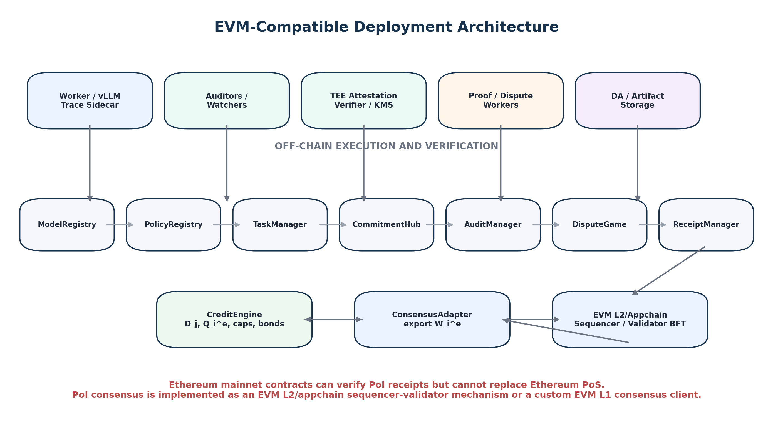
Figure 6. EVM implementation separates off-chain AI execution/auditing from bounded on-chain state transitions and dispute arbitration.

8.1 Solidity contract set
Contract | Responsibility
ModelRegistry | Model manifests, open-weight roots, confidential execution policies, runtime versions, assurance classes.
PolicyRegistry | C_P, audit compiler hash, semantic verifier hashes, DA/dispute parameters, revocations, upgrade timelocks.
TaskManager | Consensus/service class, C_T, model, task family, D_j, deadline, nonce, assignment commitment.
CommitmentHub | C_R, worker bond, artifact root, trace root, IEC root, finalize height.
AuditManager | Derives/records audit rounds, required openings, audit deadlines, receipt states.
DisputeGameFactory | Creates interactive bisection/fault-proof games and handles timeout/slashing logic.
ReceiptManager | Mints/updates non-transferable Intelligence Receipts: PENDING -> ACTIVE -> EXPIRED/SLASHED.
CreditEngine | Per-task budget allocation, assurance factor, task-family caps, epoch-local Q_i, collateral cap, slashing.
ConsensusAdapter | Exports matured W_i^e to the EVM appchain/L2 consensus client or sequencer-election service.

8.2 Deployment modes
Mode | What EVM provides | Where PoI consensus lives
Ethereum mainnet settlement | Commitments, disputes, receipts, credit state | PoI cannot replace Ethereum PoS; use for L2/appchain validator or sequencer selection.
EVM rollup / appchain | EVM contracts + custom sequencer/validator set | PoI weight selects sequencers/validators; settlement may be Ethereum or another EVM chain.
Custom EVM Layer 1 | Standard EVM execution client plus custom consensus client | PoI weight is a native Sybil-resistance/resource layer consumed by weighted BFT/fork-choice.

Ethereum’s current architecture separates execution and consensus clients; the EVM execution client is not responsible for consensus logic [15]. That separation is useful here: an EVM-compatible PoI chain can preserve ordinary EVM execution while replacing only the validator-selection/resource logic in the consensus client.

8.3 On-chain boundedness
No large tensors, weights, prompts, or full responses are stored in EVM state. Contracts store hashes, roots, bonds, deadlines, receipts, and credit. The expensive audit is off chain. The EVM only handles normal-path state transitions and rare disputes. This is the same general scalability logic that makes optimistic-rollup fault proofs practical [2].

9. Data Availability, Privacy, and Intelligence Receipts
The artifact bundle contains the user-visible response, IEC, required trace openings or retrievable trace chunks, model/runtime manifest, audit transcript, semantic-check metadata, and dispute material. It is erasure-coded or stored in a DA system and committed by C_A. The chain samples availability and enforces a retention horizon rather than requiring permanent on-chain storage.
P_miss <= (1 - f)^k_DA for independent sampling under the configured withholding model
Coded Merkle Tree and related data-availability work show how randomized sampling can provide probabilistic retrievability evidence without requiring every node to download all data [13].
Receipt lifecycle:
COMMITTED -> PENDING_AUDIT -> PENDING_CHALLENGE -> ACTIVE -> EXPIRED or SLASHED
A receipt is not transferable reputation. It is an event certificate bound to one task, one model, one response, one audit epoch, and one policy root.
R_I = (TaskID, C_T, C_M, C_R, R_X, R_E, AuditRoot, AssuranceTier, ScoreBand, C_A, Nullifier, PolicyRoot)

10. Sybil-Neutral Intelligence Economics
The protocol must prevent a worker from creating fake requesters, easy tasks, or many identities and converting them into voting power. Therefore service tasks and consensus tasks are economically separated, and every consensus task has one global credit budget independent of the number of identities that solve it.
sum_i c_ij <= D_j
A simple bounded allocation rule is:
c_ij = D_j * s_ij * a_ij / max(1, sum_h s_hj * a_hj)
s_ij is a bounded function of objective/grounded semantic score and task difficulty; a_ij is the assurance factor. For single-winner classes, the full D_j can go to the best valid receipt under a precommitted tie rule.
Epoch-local intelligence credit deliberately avoids indefinite historical reputation:
Q_i^(e+1) = sum_{j matured from epoch e} c_ij
W_i^(e+1) = min(Q_i^(e+1), B_i/beta, ConcentrationCap_i^(e+1))
Collateral cannot create PoI weight: Q_i = 0 implies W_i = 0. It only limits and insures already-earned intelligence authority. The task scheduler must also be Sybil-neutral at the opportunity layer; otherwise an attacker could use many identities to capture more distinct tasks even though each task budget remains bounded.
The scheduler therefore uses actor-cost-neutral assignment such as capability-class queues plus random assignment from pre-registered capacity slots, with per-operator capacity commitments and protocol-wide task budgets. A full permissionless implementation must formally model whether identity splitting can increase expected task allocation.

11. Consensus Selection and Finality
PoI is the resource/Sybil-resistance layer, not the agreement theorem. Matured intelligence work determines who may participate and with what weight; a conventional BFT/fork-choice protocol determines the canonical chain.
p_i^(e) = W_i^(e) / sum_k W_k^(e)
A VRF or protocol randomness source samples proposer and committee roles from active PoI weight. A HotStuff-family weighted BFT protocol is a natural appchain/L2 choice because its safety/liveness properties can be analyzed independently of the PoI work-generation mechanism [14].
Consensus work is intentionally delayed one epoch. Hearth independently uses the same high-level principle for verified inference: work performed in one epoch only influences block production after verification/challenge finality in a later epoch [11]. The architectural lesson is important even though it is not a novelty claim: expensive AI verification must never sit in the critical path of each block.
Pr[ W_A^e / W_total^e >= theta_BFT ] <= epsilon_weight
Production security requires an economic theorem or simulation showing that an adversary cannot cheaply acquire Byzantine-threshold active weight through subsidized compute, task specialization, collusion, or scheduler capture.

12. Security Model and Proof Targets
Property | Required security target | Residual assumption
Model substitution resistance | Response/trace receipt binds C_M; opened weights or attestation match registered manifest. | Open-weight commitment soundness or hardware-root assurance.
One-pass commitment integrity | After C_R finality, y, R_X, R_E, task, and model cannot be replaced. | Collision resistance + settlement finality.
Audit unpredictability | Concrete S_X/S_S unavailable before C_R finality. | Unbiased epoch randomness / grinding bound.
Execution audit soundness | Incorrect sampled tensor/transition fails except bounded randomized-check error. | Audit coverage + deterministic/quantized profile.
Optimistic completeness | One honest watcher can force invalid execution into dispute before maturity. | Watcher availability and economic incentives.
Semantic false-accept bound | False accept <= alpha_sem on sealed external-validity distributions. | Empirical; not a pure cryptographic theorem.
DA before authority | Unavailable artifacts cannot mature into active credit. | Sampling and retention assumptions.
Sybil budget safety | Identity splitting cannot inflate the total credit minted by the same task. | Scheduler opportunity neutrality still required.
No stake minting | Q=0 => W=0. | Correct credit/bond contracts.
Consensus safety | Adversarial active weight remains below BFT threshold with high probability. | Economic/resource model.

12.1 Combined false-accept decomposition
epsilon_PoI <= epsilon_commit + epsilon_rand + epsilon_exec-audit + alpha_sem + epsilon_dispute + epsilon_DA + epsilon_replay + epsilon_policy
The semantic term is deliberately separated from the cryptographic terms. A perfectly valid proof that a fallible semantic verifier executed correctly is not proof that its worldview is universally correct.

12.2 Watcher dilemma and incentive design
Optimistic systems require an honest or profit-motivated challenger. To reduce passive-watcher risk, the protocol can randomly assign mandatory audit duties to a small bonded audit committee while preserving permissionless challenges. Assigned auditors are paid for timely audit reports and can be slashed for provable non-participation; any external watcher can still challenge and receive the fraud reward. The committee is not a semantic voting oracle—it is an availability mechanism for objective protocol checks.

13. Scalability for 70B, 600B, and Trillion-Parameter Models
The protocol’s acceptance must not depend on fitting the entire model inside an EVM, a zk circuit, or a second verification cluster. Instead it scales by keeping the full inference on the optimized serving path and scaling audit work with selected execution surfaces.
Technique | Scaling effect
One inference only | Eliminates the mandatory ~2x frontier-model generation pattern.
Trace commitments | The provider records roots and retained state while serving; large trace bodies stay off chain.
Sampled tensor audits | Verification cost depends on challenged layers/tokens rather than full inference replay.
Optimistic disputes | Heavy arbitration cost occurs only on challenged results.
MoE active-path audit | Only routed experts for selected tokens need per-response checking.
Batch audits | Many receipts from the same model/epoch share audit infrastructure and cached model metadata.
Epoch-delayed authority | PoI verification may take seconds/minutes without delaying block finality.
Receipt batching | Multiple matured receipts can be processed in a single EVM transaction or aggregate commitment.
Assurance tiers | Open-weight trustless audits and closed-weight attestation use the same receipt interface with explicit risk factors.

13.1 Throughput model
T_chain ~= min(T_receipt_state, T_dispute_capacity, T_BFT)
T_service ~= min(T_GPU, T_trace, T_audit_market, T_DA)
The proof/audit queue is asynchronous and horizontally scalable. Task issuance must be back-pressured so outstanding audit obligations do not grow beyond watcher, DA, or dispute capacity.

13.2 Practical frontier-model evidence
The frontier-scale claim is a feasibility direction, not a completed benchmark of this exact protocol. Relevant evidence exists: opML demonstrates optimistic verification designed for models much larger than ordinary zkML targets and reports 7B LLaMA support in a CPU-scale fraud-proof setting [1]; CommitLLM reports a 70B audit prototype with low selected-token verification cost while retaining important attention limitations [5]; current confidential-computing stacks support multi-GPU attestation for H100-class and newer devices [4,7]. The proposed architecture combines these directions while making their trust and coverage boundaries explicit.

14. Reference Implementation Blueprint
Module | Suggested implementation
EVM contracts | Solidity 0.8.x; Foundry test suite; upgradeable policy via timelocked root changes rather than arbitrary mutable verifier logic.
Worker runtime | vLLM/TensorRT-LLM/PyTorch serving with trace sidecar; deterministic sampling manifest; sharded/MoE trace roots.
Open-weight auditor | Rust/C++ CPU auditor; Merkle verification; Freivalds-style tensor fingerprints; exact cheap-op replay.
Confidential lane | Intel TDX or AMD SEV-SNP CVM + NVIDIA H100/B200 confidential GPU attestation; policy-gated model key release.
Dispute VM | RISC-V/WASM/ML-specific deterministic micro-VM; interactive bisection; final bounded EVM arbitration.
Semantic verification | Deterministic checkers + evidence verifier + small fixed NLI/factuality/safety models; calibration and ABSTAIN.
DA | Pluggable DA layer or erasure-coded object store; on-chain root, sampling certificates, retention challenges.
Consensus client | Weighted HotStuff/appchain client or L2 sequencer-election daemon consuming next-epoch W_i.
Observability | Per-receipt trace/audit/dispute metrics, model-version metrics, false-accept dashboards, and reproducibility manifests.

14.1 Prototype milestones
- Build Solidity registries, TaskManager, CommitmentHub, ReceiptManager, CreditEngine, and simple challenge window.
- Integrate a 1B-8B open-weight model with trace sidecar and one-pass IEC generation.
- Add tensor audits for linear layers and deterministic checks for tokenizer/sampling/selected non-linear operations.
- Implement a permissionless watcher and interactive dispute game for a deterministic quantized inference profile.
- Add grounded-QA semantic audits with sealed evaluation sets and ABSTAIN.
- Run end-to-end EVM testnet: 10k+ receipts, DA withholding, Sybil splitting, dispute, and next-epoch committee selection.
- Extend to 70B multi-GPU inference, then MoE/sharded models; measure trace overhead, audit bandwidth, watcher cost, and dispute latency.
- Integrate confidential H100/B200 lane with fresh-nonce attestation and model-key release.
- Conduct independent cryptographic, semantic, smart-contract, and economic audits before any production-security claim.

15. Evaluation and Falsification Program
Hypothesis | Falsification criterion
H1 - Single-pass cost advantage | Expected end-to-end cost is not materially lower than a two-frontier-run baseline at target models/loads.
H2 - Execution audit soundness | Trace/tensor tampering routinely escapes configured audit/dispute coverage.
H3 - Frontier scaling | Trace retention, audit bandwidth, or dispute cost grows so rapidly that 70B+/MoE service throughput collapses.
H4 - Semantic value | IEC + post-commit audit adds no predictive value for blinded expert correctness beyond one-shot scoring.
H5 - Open semantic safety | False accepts stay high or ABSTAIN rate makes consensus-eligible open tasks unusable.
H6 - Optimistic watcher security | Low challenge participation allows profitable invalid receipts to mature.
H7 - DA gating | Adaptive selective serving/withholding routinely reaches ACTIVE state.
H8 - Sybil neutrality | Identity splitting increases expected protocol task credit beyond epsilon_sybil.
H9 - Economic safety | Adversary can cheaply acquire Byzantine-threshold W despite task budgets, caps, and bonds.
H10 - EVM boundedness | Normal-path gas/state growth becomes comparable to heavy AI execution or is not sustainable under batching.

Primary measurements: native inference latency and cost; trace overhead; retained-state size; routine audit time; challenge/dispute frequency and latency; semantic false-accept/false-reject/ABSTAIN; expert agreement; DA bandwidth; gas per commitment/receipt/dispute; Sybil advantage; cost to acquire 1/3 active weight; and BFT finality under delayed/missing receipts.

16. Prior-Art Boundary and Defensible Novelty
The architecture deliberately does not claim invention of optimistic fraud proofs, Freivalds verification, TEE attestation, zkML, data-availability sampling, weighted BFT, or epoch-delayed consensus authority. These are established or already proposed in adjacent systems [1-15].
Element | Prior-art status | Defensible claim here
Optimistic ML / fraud proof | opML and rollup fault-proof systems already exist [1,2]. | Used as the execution-integrity backstop, not claimed as new.
TEE + optimistic hybrid | Hybrid TEE/optimistic AI verification has been proposed [3]. | Used as an explicit assurance lane, not claimed as new.
Deterministic re-execution | EigenAI uses optimistic deterministic re-execution [8]. | This architecture removes mandatory second frontier execution from the common verification path.
LLM commit-and-audit | CommitLLM demonstrates trace commitments + randomized algebraic audits [5]. | Generalized into a consensus receipt with semantic audit, challenge maturity, DA, and EVM authority.
Epoch-delayed verified work | Hearth uses verified work from prior epochs for later block-production weight [11]. | Adopted as a scalability requirement, not a novelty claim.
Single-Pass Auditable Intelligence (SPAI) | No exact standardized primitive identified in the targeted scan. | Proposed reusable object: one frontier response + committed execution/semantic surfaces + post-commit audits + optimistic maturity + consensus eligibility.
Intelligence Evidence Capsule | Proof-carrying/structured-answer work exists broadly. | Here it is the single-pass semantic audit surface bound to the same response receipt and challenge seed.
EVM PoI receipt interface | No claim that receipt contracts are new. | A complete EVM-compatible path from AI response to matured next-epoch consensus resource.

Novelty remains provisional until an exhaustive scholarly and patent search is completed. The paper’s strongest contribution is therefore not “a new hash or SNARK.” It is a complete single-pass PoI verification object and consensus architecture that removes two cost barriers—mandatory second frontier-model execution and mandatory full per-response zkML—while preserving explicit execution, semantic, DA, economic, and EVM-consensus security boundaries.

17. Production-Readiness Gates
Gate | Minimum evidence before production-security claim
Single-pass cost | Measured cost/latency against two-run and full-zk baselines on 8B, 70B, and at least one sharded/MoE target.
Execution assurance | Independent tamper campaign across weights, traces, quantization, routing, attention, decode, and cross-request splicing.
Semantic assurance | Large blinded multi-domain external-validity study with FAR/FRR/ABSTAIN intervals and adversarial prompt/rubric attacks.
Watcher/dispute security | Adversarial simulation proving challenge participation and dispute economics under low-value and high-value tasks.
TEE lane | Multi-vendor/independent attestation validation, key-release replay tests, revocation, compromised-root response plan.
DA | Adaptive withholding/selective-serving/cartel tests through complete slashing horizon.
Sybil/economics | Task-allocation neutrality plus cost-to-acquire Byzantine active weight under subsidized compute and collateral markets.
EVM contracts | Independent smart-contract audit, gas/state stress test, timeout/reentrancy/DoS/fault-game review.
Consensus | Formal mapping of matured W_i to BFT assumptions and long-duration liveness/churn tests.
Reproducibility | Independent team rebuilds worker, auditor, contracts, dispute path, and benchmark results.

17.1 Current assessment
Assessment | Score | Verdict
Overall protocol feasibility | 94 / 100 | Coherent PoI consensus architecture with explicit trust and failure boundaries.
Research-prototype implementability | 91 / 100 | Core EVM contracts, one-pass tracing, audit, semantic checks, DA, and weighted testnet are implementable now.
EVM / L2 / appchain implementability | 92 / 100 | Architecture maps naturally to smart-contract settlement and custom sequencer/validator selection.
Frontier-model compatibility | 86 / 100 | No full second run or full per-query zk requirement; remaining risk is audit coverage for complex kernels and distributed runtimes.
Common-path cost efficiency | 90 / 100 | Expected cost is one inference + tracing + sampled audits; rare disputes carry heavy cost.
Semantic verification strength | 76 / 100 | Strong for objective/grounded tasks; open-ended correctness remains empirical and must abstain when underdetermined.
Cryptographic / optimistic execution assurance | 84 / 100 | Mature primitives exist, but complete transformer coverage and dispute economics require implementation evidence.
Scalability architecture | 89 / 100 | Asynchronous epochs, batch receipts, sharded audits, and off-chain DA remove block-speed coupling.
Production-ready theoretical protocol | 90 / 100 | Specified to implementation level with explicit assurance tiers and security targets.
Production deployable today | 72 / 100 | Still needs executed security, semantic, frontier-scale, economic, and independent audit gates.

Overall judgment
This architecture is substantially more realistic than a design that requires two frontier-model runs or a full zkML proof for every response. The strongest remaining risks are not conceptual: they are transformer audit coverage, open-ended semantic false accepts, watcher/dispute economics, and adversarial PoI-weight acquisition.

18. Conclusion
A globally useful Proof of Intelligence consensus cannot require every node to reproduce a frontier model and cannot assume that current full zkML can economically prove every 70B-to-trillion-parameter response. It also cannot confuse hardware identity with intelligence or replace verification with validator reputation. The protocol must make the actual user-facing response auditable at a cost much lower than reproducing it.
The architecture defined here makes one frontier-model inference the atomic production event. Execution traces and semantic evidence are committed inline. Post-commit randomness selects what to inspect. Open-weight models use randomized algebraic tensor audits and optimistic fault proofs; closed models use confidential-computing attestations with explicit trust tiers. Semantic correctness is checked against objective, grounded, or calibrated task contracts without running the frontier model a second time. Data availability and challenge windows mature the response into an Intelligence Receipt. Only matured protocol-issued receipts create bounded next-epoch authority, and EVM smart contracts manage the entire commitment, dispute, receipt, and credit lifecycle while the consensus client consumes PoI weight for block production and finality.
The result is a realistic engineering target: one useful AI response, one auditable execution event, one bounded intelligence certificate, and one consensus resource. The remaining work is measurable—build it, attack it, benchmark it on frontier models, quantify semantic error, and prove the economics.

Appendix A. Core Verification Pseudocode
VerifySPAIEvent(S):
1. require ActivePolicy(S.C_P) and ValidTask(S.C_T)
2. require Finalized(S.C_R) before S.eta
3. recompute (S_X, S_S) = AuditCompiler(S.C_P, S.C_T, S.C_R, S.eta)
4. verify model/runtime binding C_M
5. verify required execution audit openings or mature optimistic challenge state
6. verify semantic obligations against committed response + IEC
7. if semantic state undefined, calibration invalid, or disagreement > gamma: ABSTAIN
8. verify DA certificate, nullifier, deadlines, and receipt maturity
9. if any hard predicate fails: REJECT
10. return ACCEPT
The settlement contract may not execute all audit logic directly. Normal-path execution and semantic audits are performed off chain; the contract verifies maturity, commitments, challenge outcomes, and bounded proofs for disputes where required.

Appendix B. EVM Interface Sketch
interface IProofOfIntelligence {
function registerModel(bytes32 modelRoot, bytes32 runtimeRoot, uint8 assuranceClass) external;
function createTask(bytes32 taskRoot, bytes32 modelRoot, uint256 creditBudget, uint64 deadline) external returns (uint256 taskId);
function commitResponse(uint256 taskId, bytes32 responseRoot, bytes32 traceRoot, bytes32 evidenceRoot, bytes32 artifactRoot) external payable;
function openChallenge(uint256 receiptId, bytes32 disputeRoot) external payable;
function finalizeReceipt(uint256 receiptId) external;
function activeWeight(address worker, uint64 epoch) external view returns (uint256);
}
The production interface should separate registries, disputes, receipts, and credit for upgrade isolation and gas accounting; this consolidated sketch only shows the minimum data flow.

References
[1] K. D. Conway, C. So, X. Yu, and K. Wong. “opML: Optimistic Machine Learning on Blockchain.” arXiv:2401.17555, 2024.
[2] OP Stack Specification. “Fault Proof.” Optimism Collective, accessed August 2026.
[3] A. Chan, A. Ding, F. Chen, A. Wu, B. Zhang, and A. Tian. “Optimistic TEE-Rollups: A Hybrid Architecture for Scalable and Verifiable Generative AI Inference on Blockchain.” arXiv:2512.20176, 2025.
[4] NVIDIA. “Attestation and Key-Release Flow — Deploying Proprietary Models Securely with NVIDIA Confidential Computing on Self-Hosted Virtual Machines.” Updated June 2026.
[5] LambdaClass. “CommitLLM: A Cryptographic Commit-and-Audit Protocol for Open-Weight LLM Inference.” GitHub/project documentation, accessed August 2026. Engineering prototype; not treated as peer-reviewed evidence.
[6] M. V. Mascagni, H. Ji, and Y. Li. “Gaussian Variant of Freivalds’ Algorithm for Efficient and Reliable Matrix Product Verification.” 2017.
[7] Intel Trust Authority. “GPU Remote Attestation with Intel Trust Authority.” 2026.
[8] D. Ribeiro Alves, V. Patankar, M. Pereira, J. Stephens, N. Vaziri, and S. Kannan. “EigenAI: Deterministic Inference, Verifiable Results.” arXiv:2602.00182, 2026.
[9] W. Qu et al. “zkGPT: An Efficient Non-interactive Zero-knowledge Proof Framework for LLM Inference.” USENIX Security, 2025.
[10] “A Survey of Zero-Knowledge Proof Based Verifiable Machine Learning.” Artificial Intelligence Review, 2026.
[11] Hearth. “A Verified-Inference Layer-1 Secured by Proof of Inference.” Draft whitepaper, July 2026.
[12] Ambient. “Proof of Logits / Machine Intelligence as Currency.” Public documentation and litepaper, 2026.
[13] M. Yu, S. Sahraei, S. Li, S. Avestimehr, S. Kannan, and P. Viswanath. “Coded Merkle Tree: Solving Data Availability Attacks in Blockchains.” Financial Cryptography and Data Security, 2020.
[14] M. Yin, D. Malkhi, M. K. Reiter, G. G. Gueta, and I. Abraham. “HotStuff: BFT Consensus with Linearity and Responsiveness.” PODC, 2019.
[15] Ethereum.org. “Node Architecture” and “Consensus Mechanisms.” Updated 2026.

